**Exp 1 Measurement of Op-Amp Parameters**

**Aim:** To Measure A] Input bias current & Input offset current B] Input offset voltage

C] Slew rate and D] CMRR. (OP-07C, LF 356,LM741C)

**Apparatus:** Bread Board, Op-Amp IC 741C, LF 356, OP 07C Resistors, DC regulated power supply, Signal generator, CRO, Digital Multi-Meter.

**Theory:**

1. **Input bias current (IB):** The input bias current is the average of the currents that flows into the inverting and non-inverting input terminals of the Op-Amp with the output at zero volts. This input bias current makes a voltage drop across the equivalent source impedance seen from the input side of Op-Amp. It affects all applications of Op-Amp. Typically the input bias current of LM741 is around 80nA.

……… (1.1)

1. **Input offset current (IOS):** The input offset current is the difference in magnitude between the two input currents IB1 and IB2 respectively, of the Op-Amp with the output at zero volts.

Typically the input offset current ofLM741 Op-Amp is 20 nA.

………. (1.2)

**A] Measurement of input bias and offset current:**

1. The bias current into the non-inverting terminal,
2. The bias current into the inverting terminal,
3. Calculate input bias current
4. Calculate input offset current

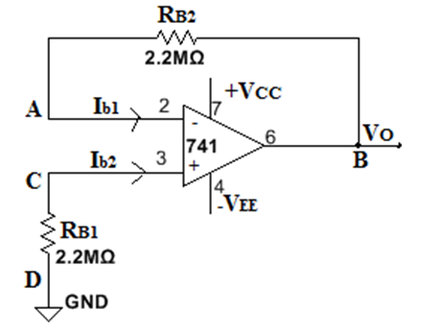

**Input bias and offset current**

1. **Input offset voltage (VOS):** It is the voltage to be applied between the two input terminals for making the output voltage zero.

In the ideal Op-Amp when both inputs are at zero volts the output should be zero volts. Due to imbalances within the device a small amount of voltage will appear at the output. This extra voltage can be eliminated by giving a small voltage called Input offset voltage (VOS) to the amplifier.

Typically the input offset voltage of LM741 Op-Amp is around 1mV.

**B] Measurement of input offset voltage:**

1. Measure the voltage.
2. Calculate input offset voltage

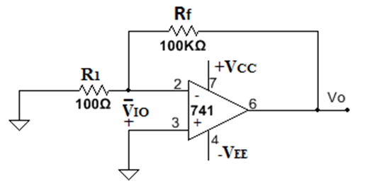

**Input offset voltage**

1. **Slew rate:** It is the maximum rate of change of output voltage for a step input voltage. It is an important parameter which limits the bandwidth for large signal and it indicates how fast its output voltage can change. It is usually specified in units of V/µs.

The slew rate of Op-Amp is rated to its frequency response. The Op-Amp with wide bandwidth have better slew rate. Slew rate limiting affects all amplifiers where capacitance on internal nodes, or as part of external load, has to be charged and discharged as voltage levels vary.

Typically the slew rate of LM741C is 0.5 V/µs, which means that the output voltage can change at the maximum of 0.5V in 1µs.

**C] Measurement of Slew Rate:**

1. Connect high frequency square wave at non-inverting input of Op-Amp.
2. Increase the input frequency till the output waveform becomes trapezoidal in shape.
3. Observe waveform on CRO and calculate dVO/dt.

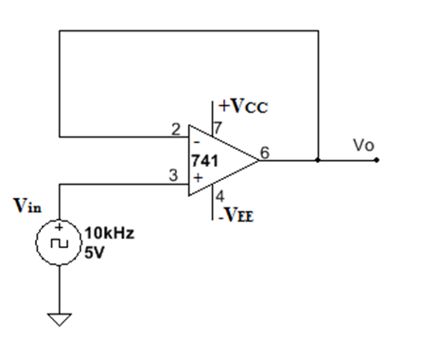

**Slew Rate**

1. **Common-Mode Rejection Ratio (CMRR) (ρ):** In Op-Amp, the output voltage is proportional to the difference between the voltages applied to its two input terminals. When the two input voltages are equal, ideally the output voltages should be zero. A signal applied to both input terminals of the Op-Amp is called as Common-Mode signal.

Usually it is an unwanted noise voltage. The ability of an Op-Amp to suppress Common-Mode signals is expressed in terms of its Common-Mode Rejection Ratio (CMRR).

Typically the CMRR ofLM741 Op-Amp is around 95dB.

………. (1.3)

**D] Measurement of CMRR: (ρ)**

1. Increase amplitude of input signal at 1till a measurable output is observed on CRO.
2. Measure input and output voltage.
3. Calculate
4. Convert CMRR value in db using

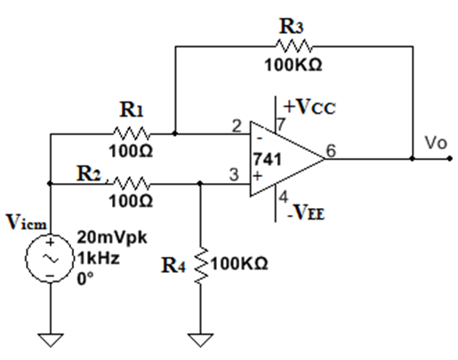

**Measurement of CMRR**

**Calculations**

**Measurement of input bias and offset current:**

input bias current

input offset current

**Measurement of input offset voltage:**

input offset voltage

**Measurement of CMRR: (ρ)**

Convert CMRR value in db using

**Measurement of Slew Rate :** dVO/dt.

**EXP 2 Summing and Averaging amplifier and Integrator for given specifications.**

**Aim:** Design and build Summing amplifier, Averaging amplifier and Integrator for given specifications.

**Apparatus:** Bread Board, Op-Amp LF 356, Resistors, Capacitors, DC Regulated Power Supply, Signal Generator, CRO, Digital Multi-Meter.

**Theory:**

**Integrator**

A circuit in which output voltage waveform is the time integral of the input voltage waveform is called Integrator or Integrating Amplifier. Such a circuit is obtained by using basic inverting amplifier configuration if feedback resistor Rf is replaced by a capacitor Cf

The limitation of an ideal integrator is that even in the absence of input signal, the two components, namely, the offset voltage and the bias current contribute for an error voltage at the output. Also, at this time, XC = ∞ and the circuit will act as open circuit. Thus, it is not possible to get a true integration of the input signal at the output. The output waveform is distorted due to this error voltage. Also, the bandwidth of an ideal integrator is very small. Hence, an ideal integrator can be used for very small ranges of input frequency only. In the ideal integrator circuit, a small dc offset at the input can force the output to saturation. To avoid this, a resistor is placed in parallel with the feedback capacitor to limit the low frequency gain

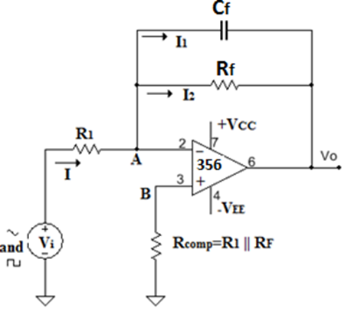

**Practical Integrator**

**Calculations:**

, ,

**Theoretical Value of Gain of Integrator**

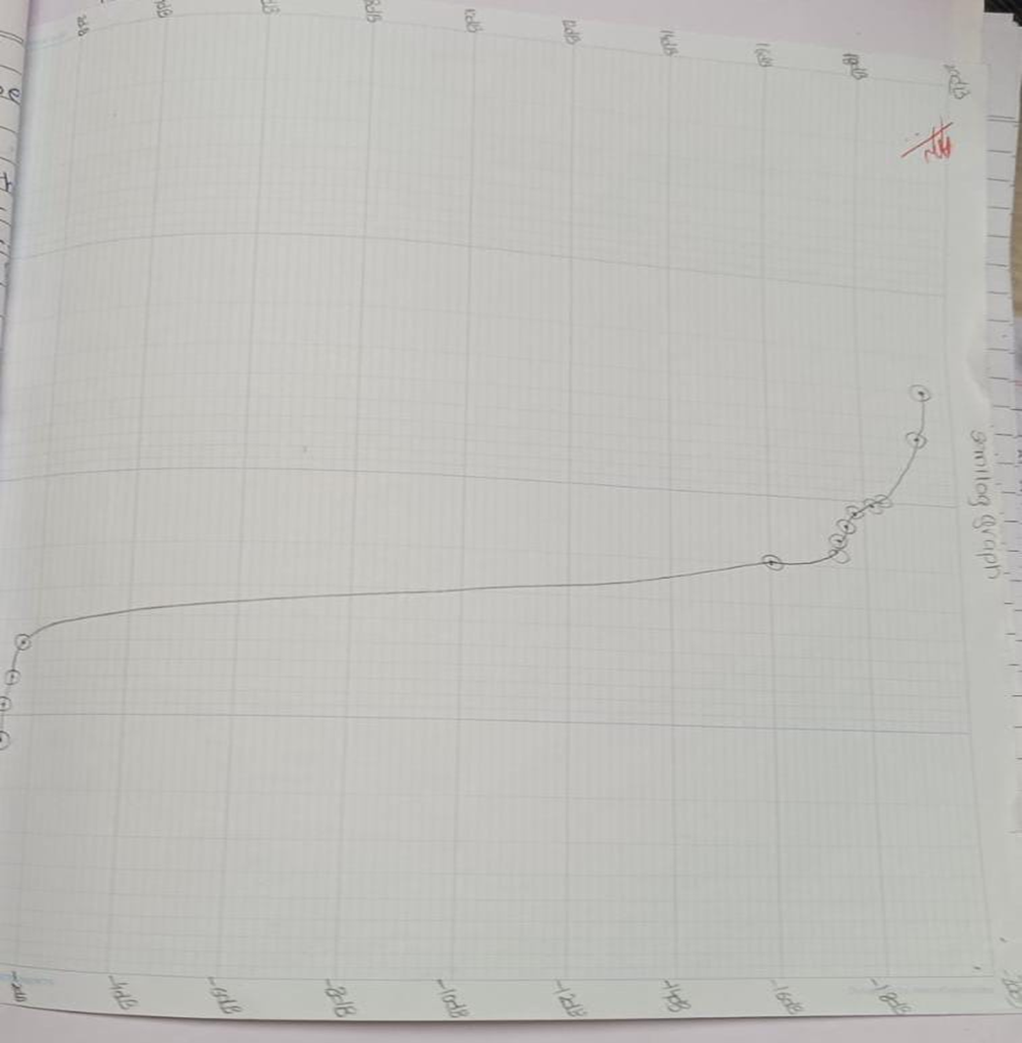

**Exp 3 Instrumentation amplifier**

**Aim:** Design and build Instrumentation amplifier (3 Op-amp based) for given specifications and validate performance using IC AD620 or equivalent.

**Apparatus:** Bread Board, Op-Amp OP 07C, DC Regulated Power Supply, Digital Multi-Meter.

**Theory**

Instrumentation amplifiers are used in monitoring and controlling of the physical quantities in the industrial processes like measurement and control of temperature, humidity, light intensity etc. A transducer which can convert one form of energy into another is used to sense and deliver the required information in the form of an electrical quantity such as voltage, current or resistance.

The major function of an instrumentation amplifier is precise amplification of low level output signal of the transducer and the instrumentation amplifier is widely used in applications where low noise, low thermal and time drifts, high input impedance and accurate closed loop gains are required

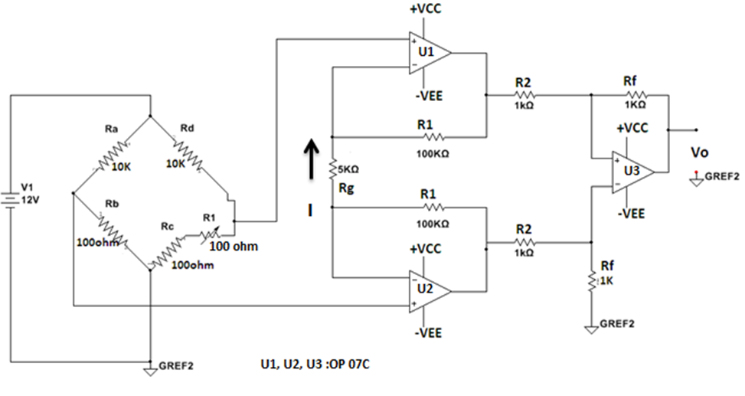

**Three Op-Amp Instrumentation Amplifier with Bridge Circuit**

**Conclusion:**

**We built a three phase op amp instrumental amplifier and using the gain constant also we calculated its output voltage and temperature.**

**Exp 4 To design build and test Schmitt Trigger and plot transfer characteristics.**

**Aim:** To design and build Symmetrical & Asymmetrical Schmitt Trigger and verify the results.

**Apparatus:** Dual power supply, Function generator, CRO, IC356

**Theory:**

The basic comparator is used in open loop mode. Since open loop gain of Op-Amp is very large, false triggering at the output can occur even due to few tenths of millivolts peak of input or less. When the input changes slowly as compared to output, the noise is coupled from output of comparator back to input. The comparator circuit designed with positive feedback to avoid such unwanted triggering is called the Schmitt Trigger or the Regenerative Comparator.

The input voltage triggers the output voltage every time it crosses certain voltage levels. These voltage levels are called Upper Threshold Voltage () and Lower Threshold voltage . The difference between two threshold voltages and is called hysteresis voltage .

……… (4.1)

The voltage span of hysteresis is set to be greater than the peak to peak noise voltage. Therefore, there will not be any incorrect output variations due to noise signals.

The threshold voltage values can be obtained as follows. Suppose the output is at positive saturation with Vo = +Vsat, then the voltage at non-inverting input (+) terminal is given by

…….. (4.2)

Where, VUT is the upper threshold voltage. The output voltage Vo remains constant at +Vsat as long as Vin is less than . When Vin is just slightly more positive than VUT, the output VO switches from +Vsat to -Vsat, and remains at the same level, as long as Vin is greater than VUT. When VO = -Vsat the voltage at non-inverting input(+) terminal is given by

……(4.3)

This voltage is identified as Lower Threshold Voltage VLT. The input voltage Vin must be slightly more negative than VLT  to switch VO from -Vsat to + Vsat. The hysteresis width VH is the difference between the two threshold voltages that is

……..(4.4)

It can be observed from the above equation that VH is independent of Vref. Resistor of Figure 4.1 is selected such that . This compensates for the variations in input bias current of the opamp.

The most important application of Schmitt Trigger circuit is to convert a slowly varying input voltage into a square wave output. Hence the circuit is also called squarer.



Inverting Symmetrical Schmitt trigger circuit

1. Design an Inverting Symmetrical Schmitt Trigger:

Given: VUTP = VLTP = ± 3.3 Assume power supply of ±12V. Use LF 356 Op-Amp.

i)

ii) Assume **R1= 7.5KΩ**,

**R2=3.3KΩ**

iii)**R3** = R1|| R2 = **2.2KΩ**

**Conclusion: Thus we have build and tested Schmitt Trigger and plotted Transfer Characteristics**

**Exp 5 Design and build square wave and triangular wave generator for given specifications.**

**Aim:** Design and build Square wave and triangular wave generator for given specifications with variable duty cycle and voltage limiters.

**Apparatus:**

Bread Board, Op-Amp: IC 356, Resistors, CRO, Function Generator, Dual Power Supply, DMM

**Theory:**

the square wave generator using op-amp, also called a free running oscillator followed by op-amp integrator. The principle of generation of square wave output is to force an op-amp to operate in the saturation region. In fig.1 fraction β = R1/(R1+R2) of the output Vo’ is fed back to the (+) input terminal. Thus the reference voltage is βVo’ and may take values as + βVsat or – βVsat. The output Vo’ is also fed back to the (-) input terminal after integrating by means of a low pass RC combination. Whenever input at the (-) input terminal just exceeds Vref, switching takes place resulting in a square wave output.

The frequency of square wave output is given as,

Variable frequency of square wave can be obtained by varying resistor R. The highest frequency generated by square wave is set by slew rate of op-amp.

The square wave thus generated is further given to an Op-Amp integrator to produce triangular wave output.

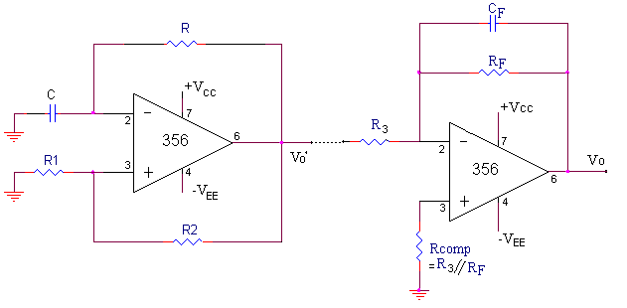

**Symmetrical Square Wave & Triangular Wave Generator**

**Calculations:**

1. For square wave time period is given by,

As

Frequency is …………..(6.2)

1. **C is chosen as 0.1 µF** , β = 0.5, let **R1 = R2 = 5.6K Ω**

Using Equation 6.2, **R = 4.55 KΩ (Take 4.7KΩ)**

1. Integrator Design:

**R3 = 10K, RF = 100K, CF = 0.01μF\**

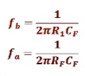

**Conclusion:**

**Thus we have Successfully build square and triangular wave generator for given specifications with variable duty cycle and voltage limiters.**

**Exp 6 Design and build Precision rectifier for given specifications**

**Aim:** Design and build Precision rectifier for given specifications

**Apparatus:**  Bread Board, Op-Amp: IC LM 741C, Resistors, Diodes 1N 4148, CRO, Function Generator, Dual Power Supply, DMM

**Theory:**

A half wave rectifier (HWR) is a circuit that passes only the positive (or negative) portion of a wave, while blocking the other half. A full wave rectifier (FWR) is a circuit that besides passing the positive portion inverts and then passes negative portion.

The major limitation of conventional rectifier is that it cannot rectify ac voltages below forward voltage drop VD of the diode. A precision rectifier using op-amp along with diodes can overcome this limitation & circuit acts as an ideal diode. The circuit shown in figure can rectify signals with peak values down to a few mill volts, unlike conventional diodes. This is possible because the high open-loop gain of the op-amp automatically adjusts the voltage drive to the diode D1 so that the rectified output peak is the same as the input. Actually diode acts as an ideal diode, since the voltage drop across the “ON” diode is divided by the open-loop gain of the op-amp. Precision rectifier finds application in variety of different circuits, especially where small input signal has to rectify.

**Inverting Type Precision Half Wave Rectifier**

CASE 1: Vi > 0: Current through R1 flows from left to right. Only one path for this current to flow is through diode D1. Hence diode D1 is forward biased and [diode](http://www.eeeonline.org/) D2 is reverse biased. As current flow through R2 is zero, Vo = Vn = 0 V.

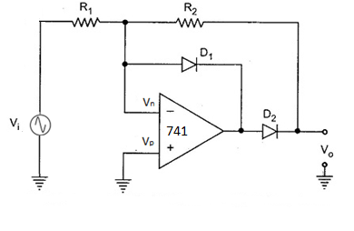CASE 2: Vi < 0: For Vi < 0, Vi is negative with respect to Vn and hence current through R1 flows from right to left. Only one path for this current to flow is through diode D2 and resistor R2. Hence diode D1 is OFF, and diode D2 is ON. With these diode states, circuit acts like an [inverting amplifier](http://www.eeeguide.com/inverting-amplifier/) and output voltage is given as

,, If R1 and R2 are made equal, then

**Inverting Half Wave Precision Rectifier**

**Inverting Type Precision Full Wave Rectifier**

CASE 1: Vi > 0: In the positive half cycle of the input, Vo1  is negative. Hence diode D1 is forward biased and [diode](http://www.eeeonline.org/) D2 is reverse biased. A2 is an inverting amplifier with unity gain. Therefore, ………… (5.2)

CASE 2 : Vi < 0 : In the negative half cycle of the input, Vo1  is positive. Hence diode D2 is forward biased and [diode](http://www.eeeonline.org/) D1 is reverse biased.

………… (5.3)

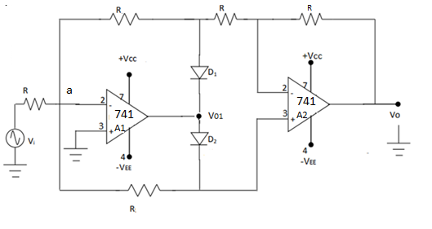

**Inverting Full Wave Precision Rectifier**

**Conclusion:**

**Thus we have build precision rectifier for given specifications**

**Exp 7 Design and implement 2 bit R-2R Ladder DAC.**

**Aim**: Design and implement 2 bit R-2R Ladder DAC

**Apparatus:** Bread Board, Op-Amp-OP-07C, Resistors, Dual Power Supply and, DMM

**Theory:**

**Digital-to-Analog Converter (DAC)**

A digital-to-analog converter, or simply DAC as shown in Figure 8.1, is a semiconductor device that is used to convert a digital code into an analog signal.  Digital-to-analog conversion is the primary means by which digital equipment such as computer-based systems are able to translate digital data into real-world signals that are more understandable to or useable by humans, such as music, speech, pictures, video.

DACs are commonly used in [music players](https://en.wikipedia.org/wiki/Digital_audio_player) to convert digital data streams into analog audio signals. They are also used in [televisions](https://en.wikipedia.org/wiki/Television) and [mobile phones](https://en.wikipedia.org/wiki/Mobile_phone) to convert digital video data into analog video signals which connect to the screen drivers to display monochrome or color images. It also allows digital control of machines, equipment, household appliances

**Performance Specifications of DAC:**

**• *Resolution***

The resolution of a converter is the smallest change in voltage which may be produced at the output (or input) of the converter. For example, an 8-bit D/A converter has 2^8-1=255 equal intervals. Hence the smallest change in output voltage is (1/255) of the full scale output range.

* Resolution should be high as possible. It depends on the number of bits in the digital input applied to DAC.
* Higher the number of bits, higher is the resolution.

It can also be defined as the ratio of change in analog output voltage resulting from a change of 1 LSB at the digital input. For n-bit DAC

Resolution= ………. (8.1)

Where Vfs=full scale voltage

• ***Accuracy***

Absolute accuracy is the maximum deviation between the actual converter output and the ideal converter output. Accuracy is a comparison of the actual output of a DAC with the expected output.

• ***Linearity***

A linear error is a deviation from the ideal straight-line output of a DAC. A special case is an offset error, which is the amount of output voltage when the input bits are all zeros. The relation between the digital input and analog output should be linear as shown in Figure 8.2.

• ***Monotonicity***

A monotonic DAC is the one whose analog output increases for an increase in digital input. A monotonic characteristic is essential in control applications, otherwise oscillations can result. If a DAC has to be monotonic, the error should be less than ±(1/2) LSB at each output level.

• ***Settling******time***

Settling time represents the time it takes for the output to settle within a specified band ±(1/2) LSB of its final value, after the change in digital input. It should be as small as possible.

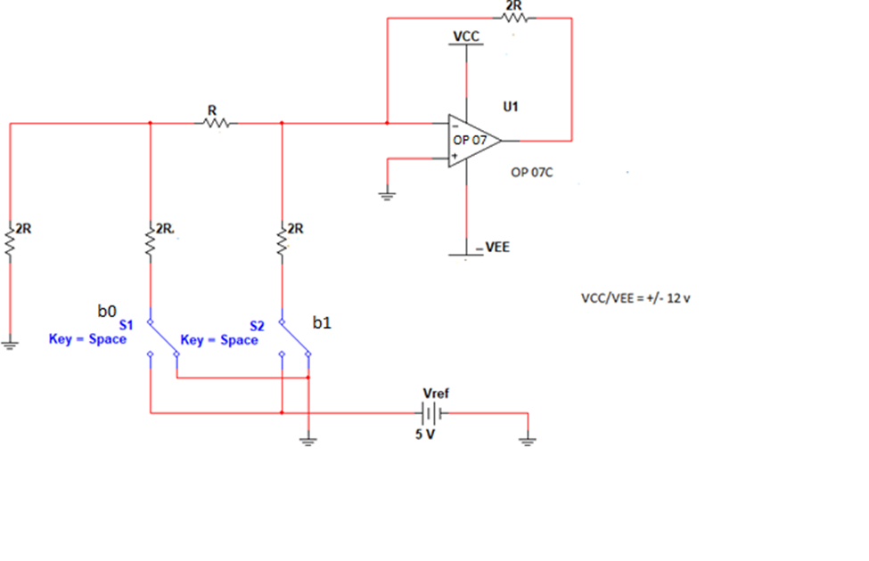

**2 bit R-2R DAC**

**Calculations: Calculate output voltage for different combinations of b1 and b0**

Vo = ……….(8.2)

Vref = 5V, gain = 2

**Conclusion: Thus we have successfully** **designed and implemented 2 bit R-2R Ladder DAC.**

**Exp 8 Design and build 1st order Low pass & High pass Active filters for given specifications.**

**Aim:** To study performance and frequency response of 1^storder Low pass & High pass Active filters

**Apparatus:** Bread Board, IC LF356, Oscilloscope, Function generator, Dual power supply

**Theory:**

A filter is a frequency selective circuit that passes a specified band of frequencies and blocks or attenuates signals of frequencies outside this band. Filter may be classified on a number of ways.

1. Analog or digital
2. Passive or active
3. Audio or radio frequency

Analog filters are designed to process only signals while digital filters process analog signals using digital technique. Depending on the type of elements used in their consideration, filters may be classified as passive or active.

Elements used in passive filters are resistors, capacitors and inductors. Active filters, on the other hand, employ transistors or Op-Amps, in addition to the resistor and capacitors. Depending upon the elements the frequency range is decided.

RC filters are used for audio or low frequency operation. LC filters are employed at RF or high frequencies. The most commonly used filters are these:

1. Low pass filters
2. High pass filter
3. Band pass filter
4. Band reject filter.
5. All pass filter

**Advantages of Active filters**:

1) **Gain and frequency adjustment in active filters**. In passive filters, the signal which is applied as input is attenuated. But in active filters amplification can be achieved with the help of Op-amp. Another advantage is the flexibility in frequency adjustment.

2) **No loading effect**: The source and load offers loading to the device because of which input is reduced at the source as well as reduced output at the load.

3) **Cheap** .The op-amp is cheap and implementation is easy with Op-Amps.

**Disadvantages of Active filters:**

1. Active devices need power supply for operation.
2. Slew rate of Op-Amp can put a limit on frequency of operation.

**Active low pass filter with pass band gain voltage gain:**

A first-order (single-pole) **Active Low Pass Filter** as shown in Figure 7.2 as its name implies, attenuates high frequencies and passes low frequency signals. It consists simply of a passive filter section followed by a non-inverting operational amplifier. The frequency response as shown in Figure 7.3 of the circuit is the same as that of the passive filter, except that the amplitude of the signal is increased by the gain of the amplifier and for a non-inverting amplifier the value of the pass band voltage gain is given as (1 + Rf/R1).

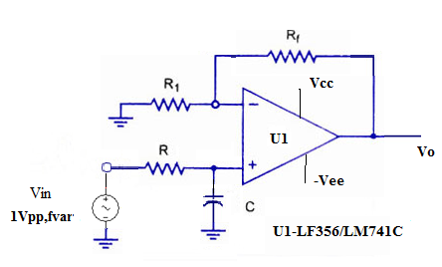

**Active Low Pass 1st order Filter**

**Active High Pass Filter**

A first-order (single-pole) **Active High Pass Filter** as shown in Figure 7.4 as its name implies, attenuates low frequencies and passes high frequency signals. It consists simply of a passive filter section followed by a non-inverting operational amplifier. The frequency response as shown in Figure 7.5 of the circuit is the same as that of the passive filter, except that the amplitude of the signal is increased by the gain of the amplifier and for a non-inverting amplifier the value of the pass band voltage gain is given as 1 + Rf/R1, the same as for the low pass filter circuit.

**Active High Pass Filter with Amplification**

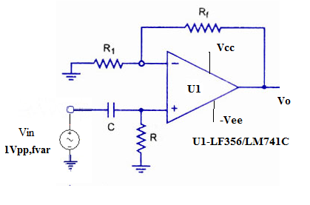

**Active High Pass 1st order Filter**

**Design Steps:**

1. Refer Figure 7.2 for 1st order Low pass Filter design and Figure 7.4 for 1st order High pass Filter design.
2. For a given cut off frequency say 1.5 Khz, assume C=0.1uF.
3. Calculate R from formula mentioned below
5. Here R =1.06 K by design, so choose R= 1Kohms
6. Assume pass band gain=2
7. Non Inverting Configuration gain is given by 1+ Rf /R1= 2 ,so R1=Rf=10Kohms

**Conclusion: Thus we have studied the performance and frequency response of order Low pass & High pass Active filters.**